Ansible

Configuration management tool (CMT tool)

Tool by which we can install s/w , create files, update packages, create users etc in production machines together

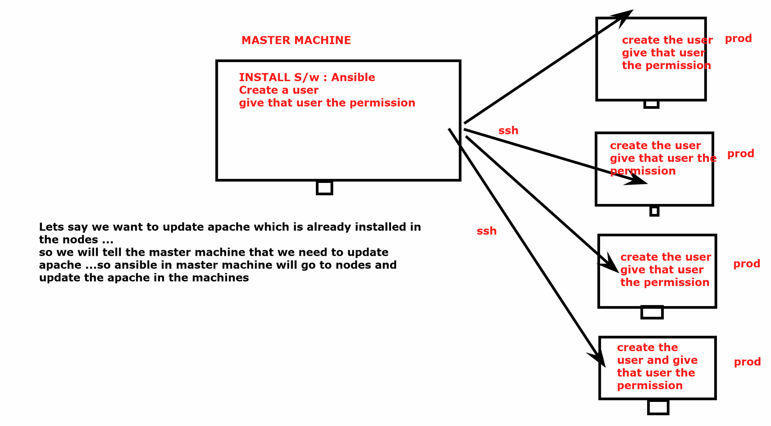

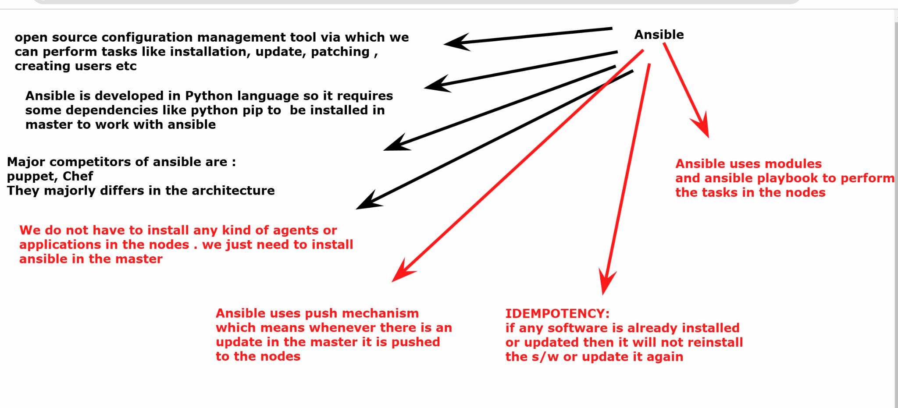

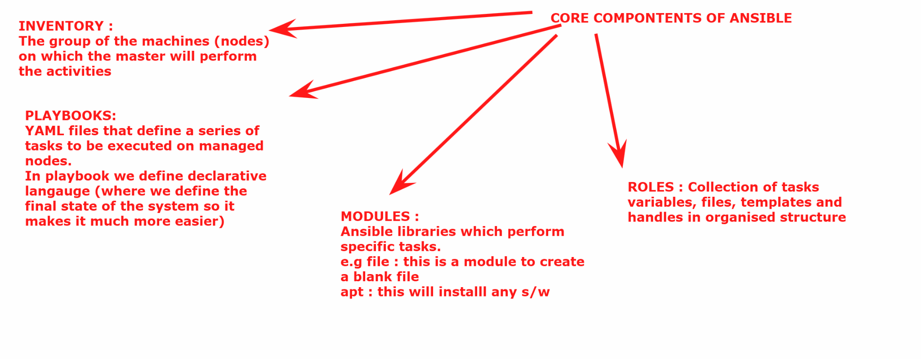

#############################################################

Ansible installation lab 👏
https://docs.google.com/document/d/1SMET2Fz9hVnSrRH_2sPEbFBFk41RQnjB/edit?usp=drive_link&ouid=103157204066713600014&rtpof=true&sd=true

################################################################

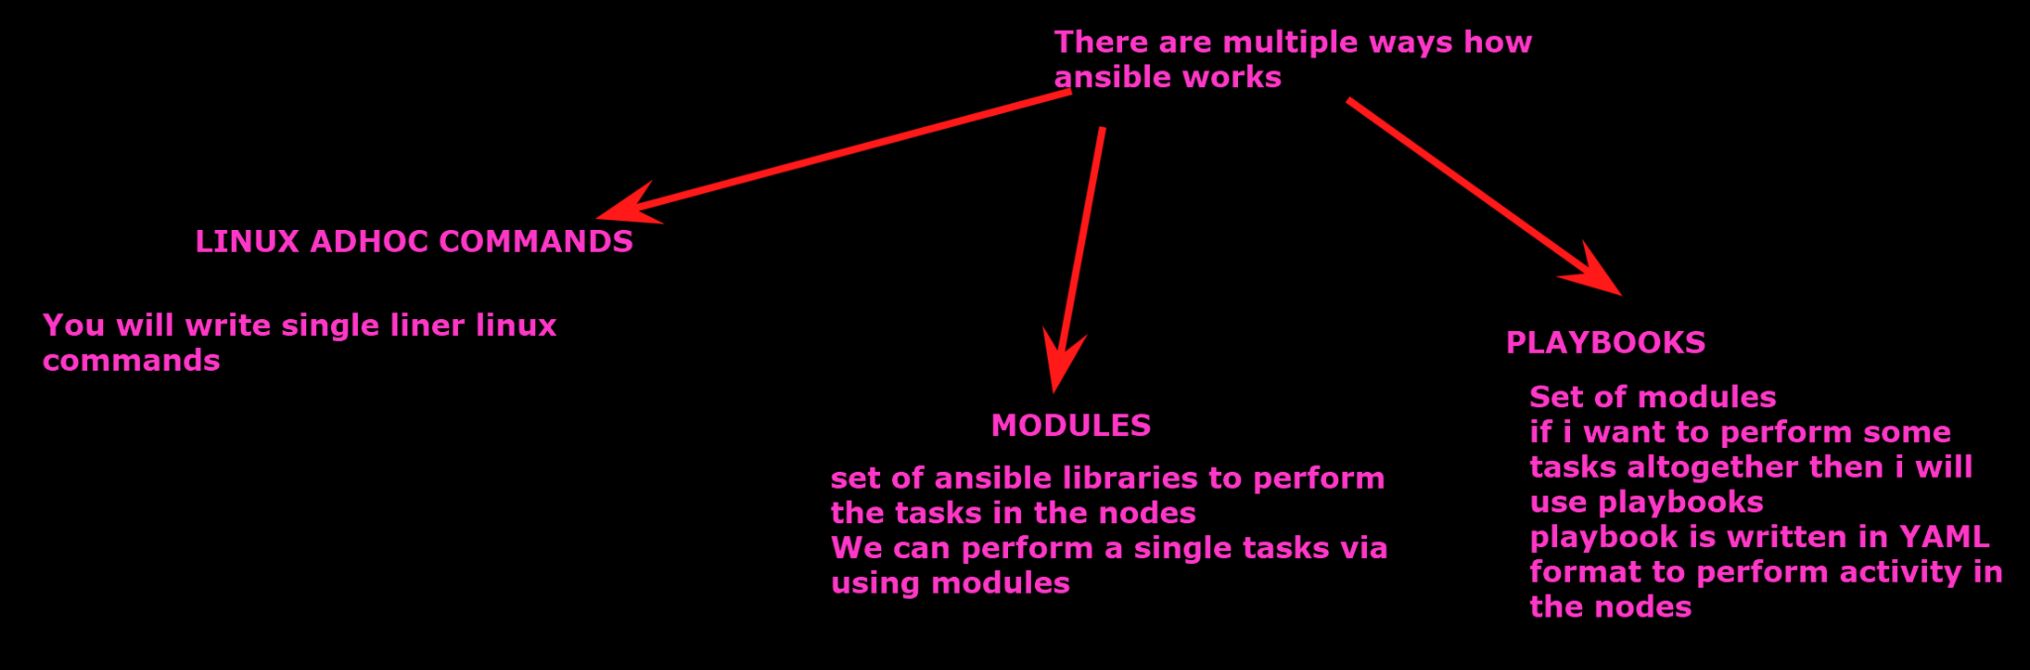

## LINUX ADHOC COMMANDS

(In master we will execute the tasks to perform the activities)

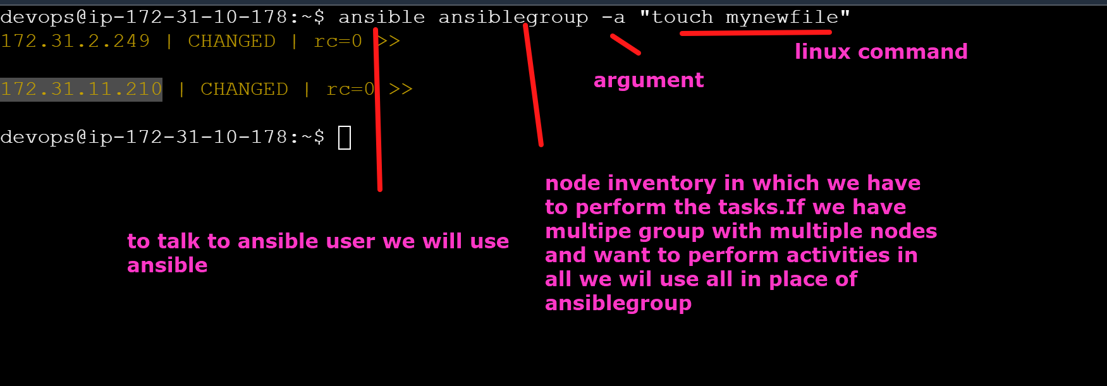

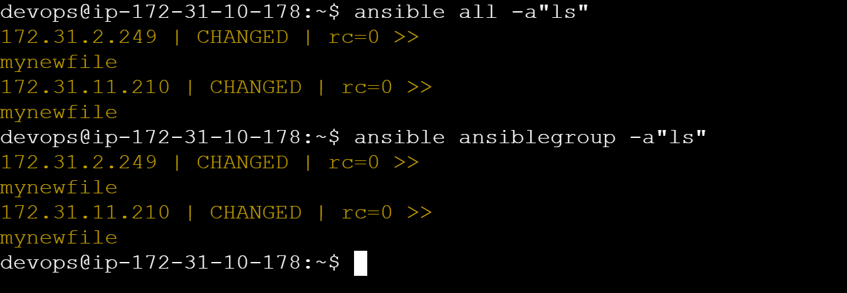

But lets suppose i want to create a file in 172.31.2.249 node only not in node2

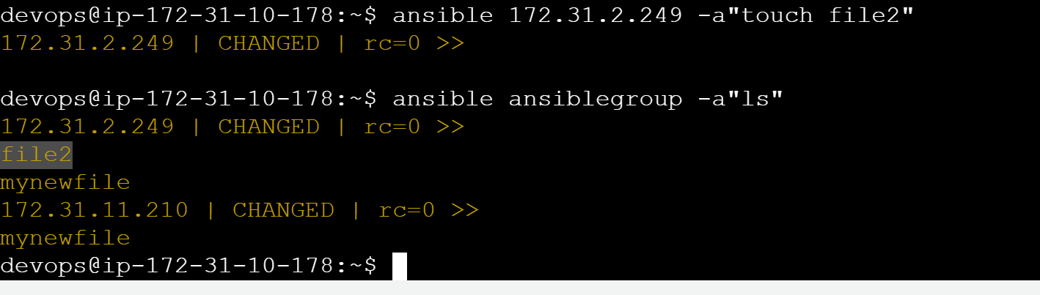

## how will i install docker software in node1 and node via linux adhoc commands?

### Download some software from internet and run that

(lets install tomcat)

ansible ansiblegroup -b -a"wget https://dlcdn.apache.org/tomcat/tomcat-9/v9.0.97/bin/apache-tomcat-9.0.97.zip"

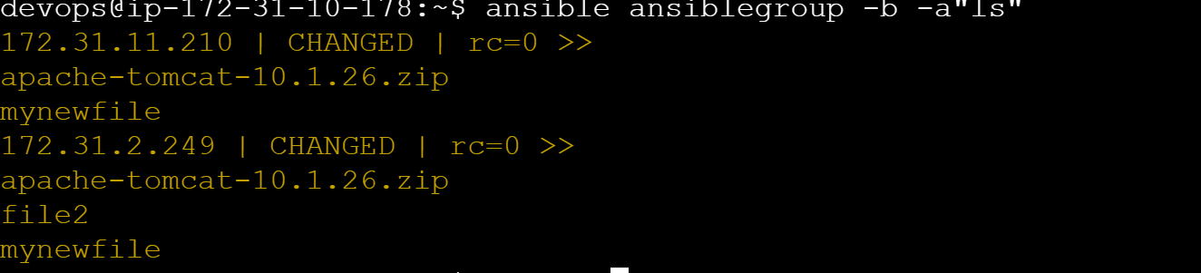

We need to give execute permission to tomcat

ansible ansiblegroup -b -a"chmod +x apache-tomcat-10.1.26.zip"

ansible ansiblegroup -b -a"ls -ltr"

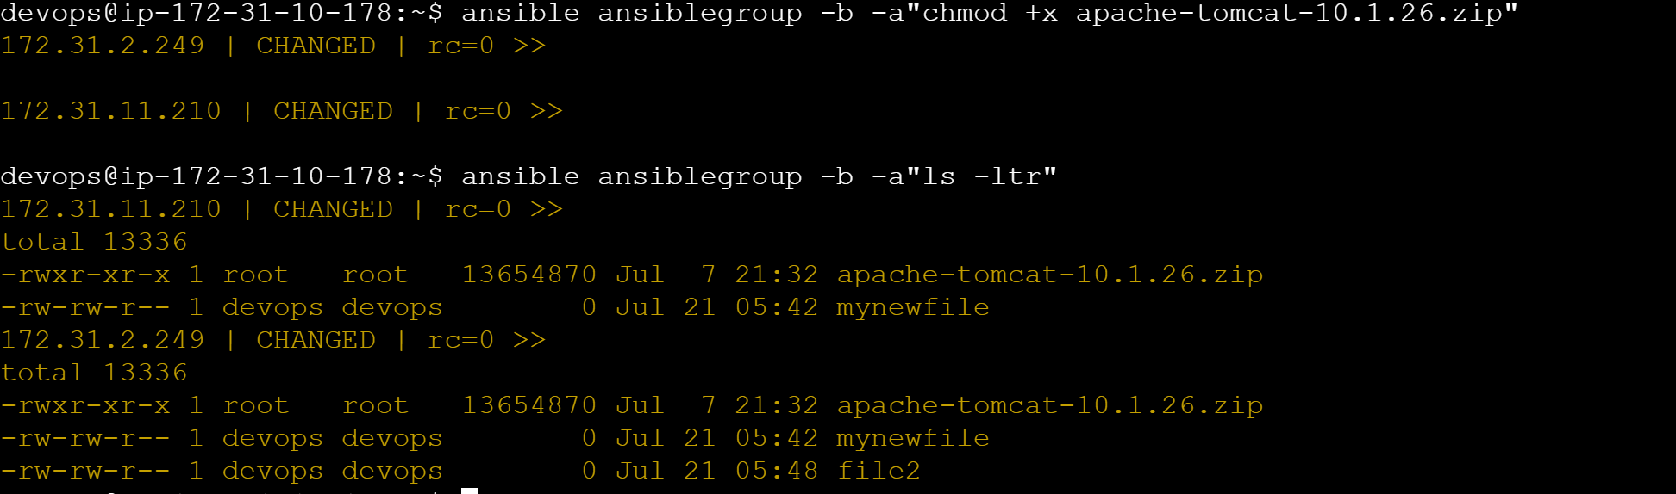

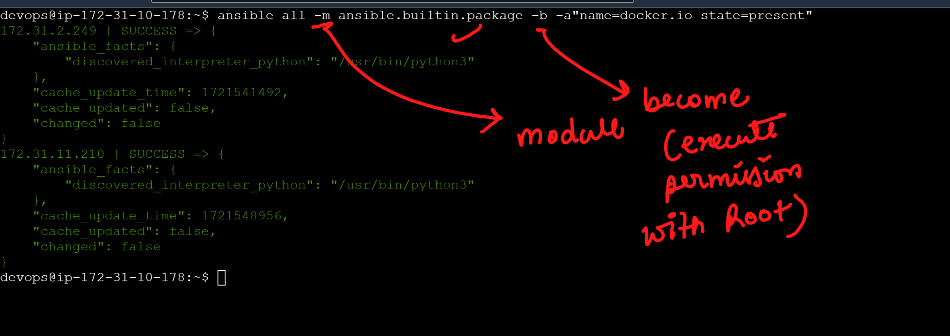

### MODULES

https://docs.ansible.com/ansible/latest/collections/ansible/builtin/package_module.html

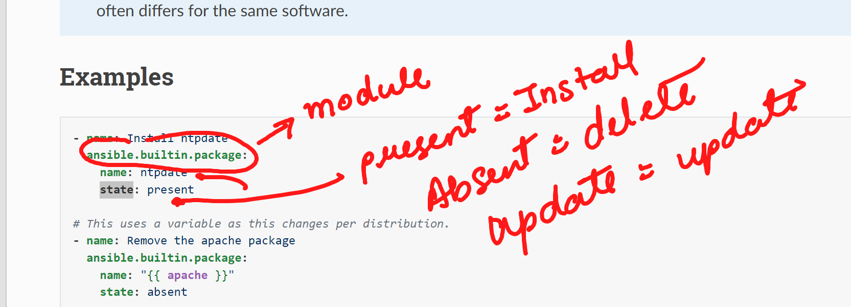
ansible all -m ansible.builtin.package -b -a"name=docker.io state=present"

# GREEN COLOR IS BECAUSE WE HAVE ALREADY INSTALLED DOCKER IN THE NODES SO ANSIBLE FOLLOWS IDEMPOTENCY WHICH MEANS IF THE SOFTWARE IS ALREADY THERE IT WILL NOT REINSTALL

## lets remove the docker via ansible

ansible all -m ansible.builtin.package -b -a"name=docker.io state=absent"

Above command is same as 👍→ ansible all -m package -b -a"name=docker.io state=absent"

ansible all -a"sudo which docker"
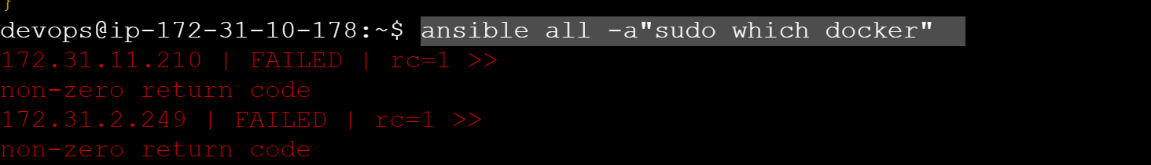
#it means docker is removed

## Lets suppose i want to create a user with name john via modules

Google : create user via ansible modules
https://docs.ansible.com/ansible/latest/collections/ansible/builtin/user_module.html

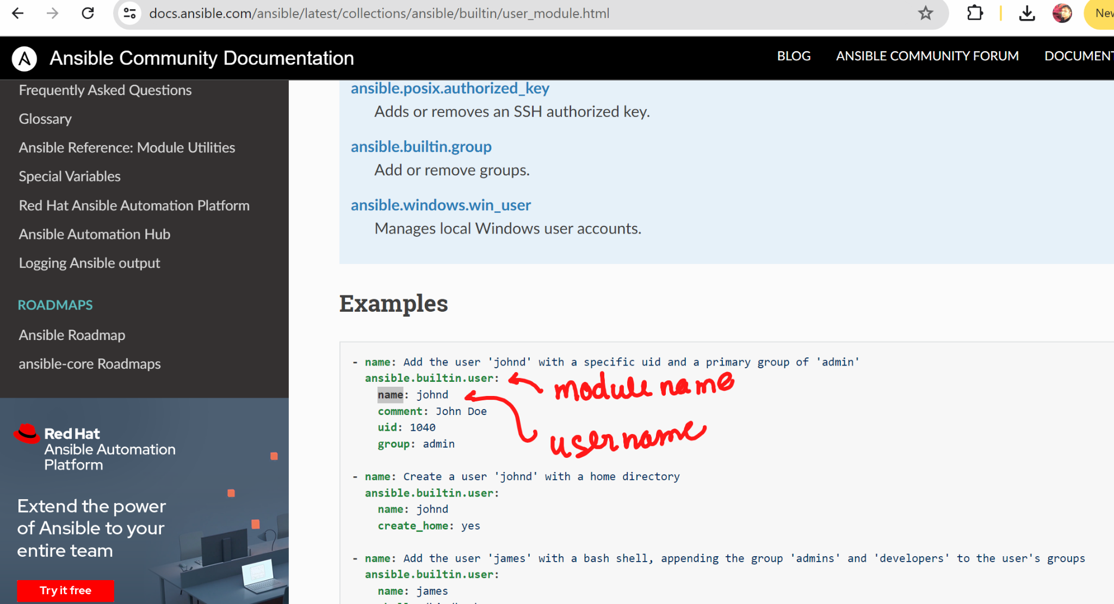

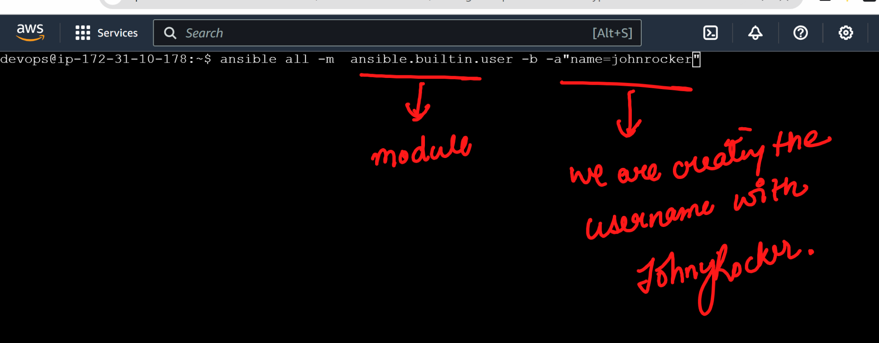

# COMMAND TO IDENTIFY IF THE USER IS CREATED OR NOT

############################

Ques: I want to copy a file from my ansible machine to the nodes

https://docs.ansible.com/ansible/latest/collections/ansible/builtin/copy_module.html
Create a file in master:

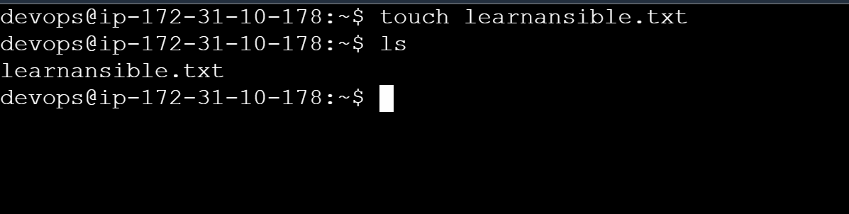

ansible all -m copy -b -a"src=learnansible.txt dest=/home/devops/"

Lets see if files are created 👍
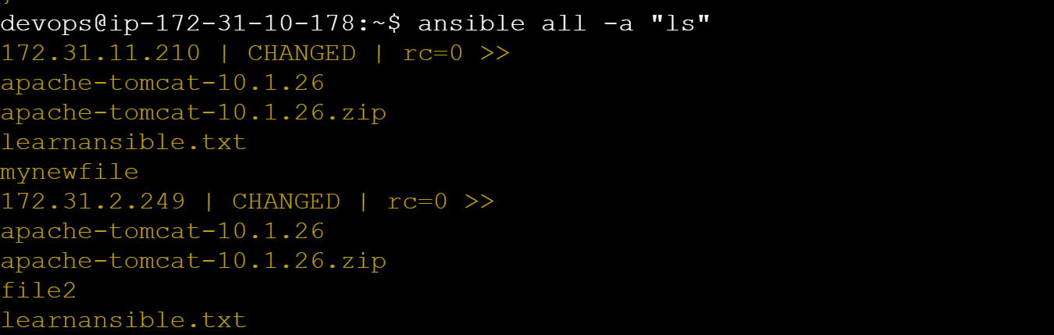

##
I want to create a file via modules in ansible

https://docs.ansible.com/ansible/latest/collections/ansible/builtin/file_module.html

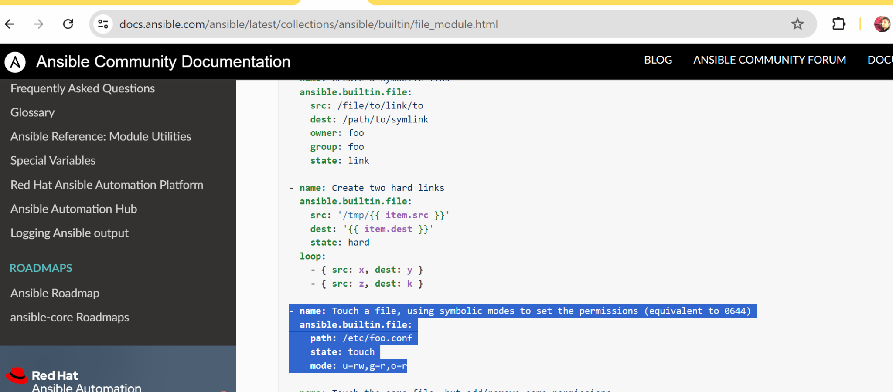

ansible all -m file -b -a"path=/home/devops/helloworldfile state=touch"

ansible all -a "ls"

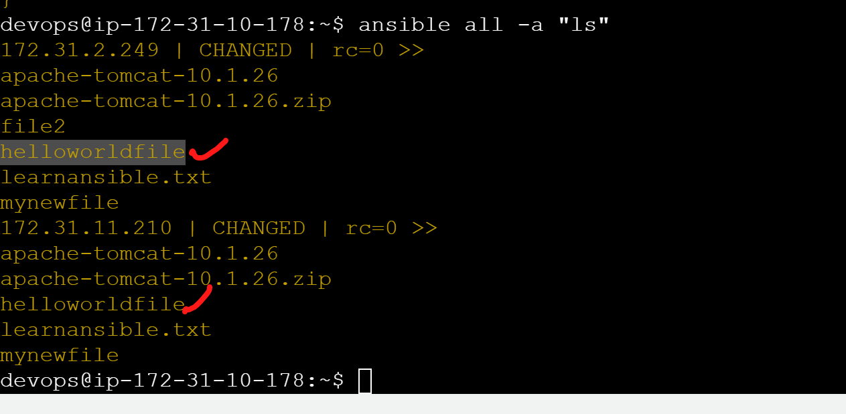

### i want to create a directory

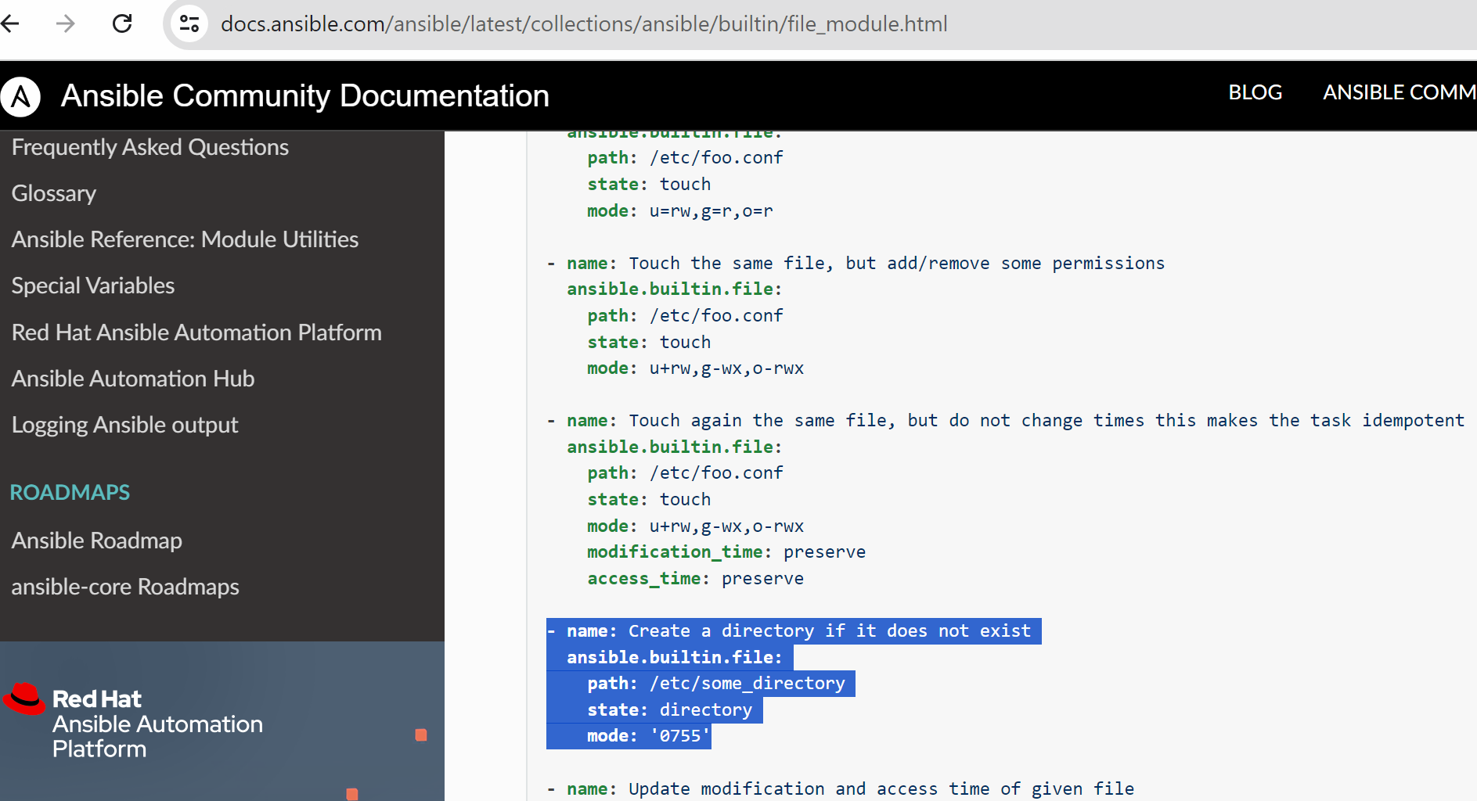

ansible all -m file -b -a"path=/home/devops/mydir state=directory"

ansible all -a "ls"

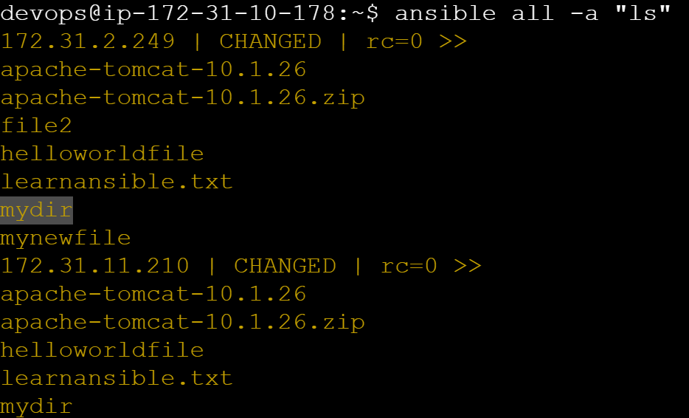

## ANSIBLE PLAYBOOKS : PLAYBOOKS ARE THE LIST OF MODULES WRITTEN IN A FILE IN YAML FORMAT. WHEN YOU EXECUTE THE YAML PLAYBOOK ALL THE TASK WOULD BE EXECUTED ONE BY ONE

TASK: We want to install the apache website in the nodes https://github.com/akshu20791/apachewebsite

Links we used while doing below lab:
https://docs.ansible.com/ansible/latest/collections/ansible/builtin/package_module.html
https://docs.ansible.com/ansible/latest/collections/ansible/builtin/service_module.html
https://docs.ansible.com/ansible/latest/collections/ansible/builtin/file_module.html
https://docs.ansible.com/ansible/latest/collections/ansible/builtin/git_module.html

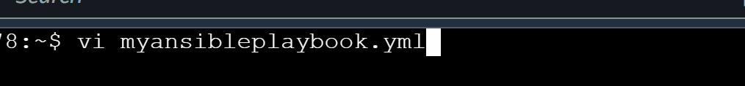

---
- hosts: all
become: yes
tasks:
- name: update all the packages
apt:
name: "*"
state: latest
- name: Install apache httpd (state=present is optional)
ansible.builtin.apt:
name: apache2
state: present
- name: Start service httpd, if not started
ansible.builtin.service:
name: apache2
state: started
- name: Install git
ansible.builtin.apt:
name: git
state: present
- name: Remove file (delete file)
ansible.builtin.file:
path: /var/www/html/
state: absent
- name: Git checkout
ansible.builtin.git:
repo: 'https://github.com/akshu20791/apachewebsite'
dest: /var/www/html/

Now we will execute the playbook
ansible-playbook myansibleplaybook.yml
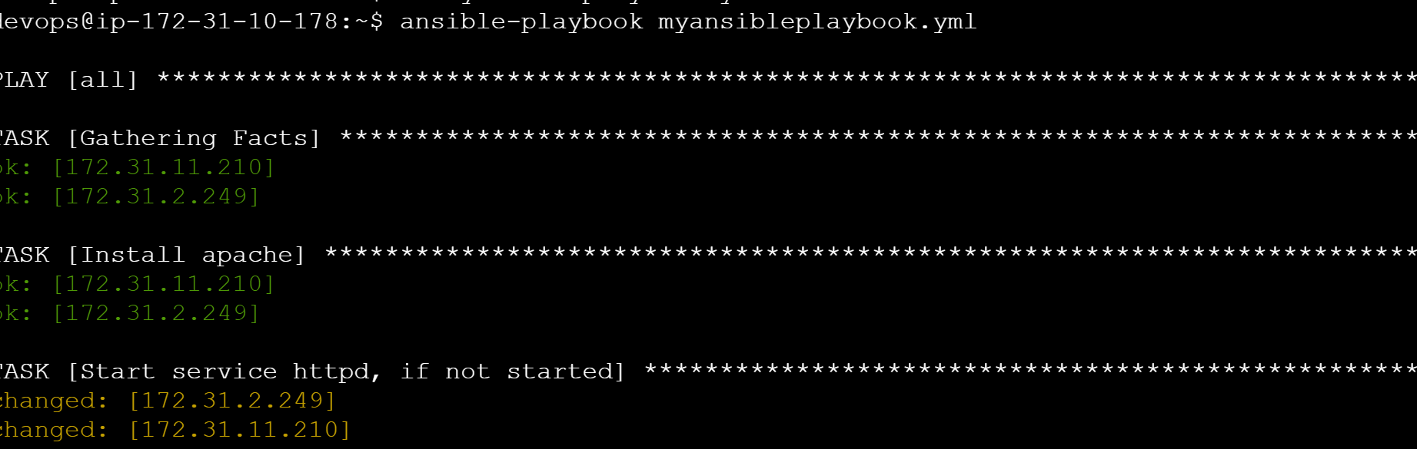

Copy the public ip of any node and check if app is working (ensure that you are notusing https )



####

Lab2: Lets create a ansible playbook which can create a user named Viratkohli in the nodes and also can copy a file from the master to the nodes

# touch viratkohlifile.txt



- hosts: all
become: yes
tasks:
- name: Add the user named viratkohli
ansible.builtin.user:
name: viratkohli
- name: Copy file with owner and permissions
ansible.builtin.copy:
src: viratkohlifile.txt
dest: /home/devops/

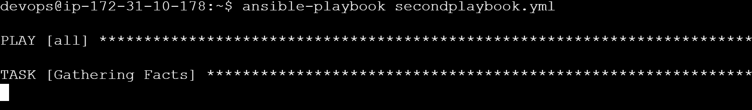

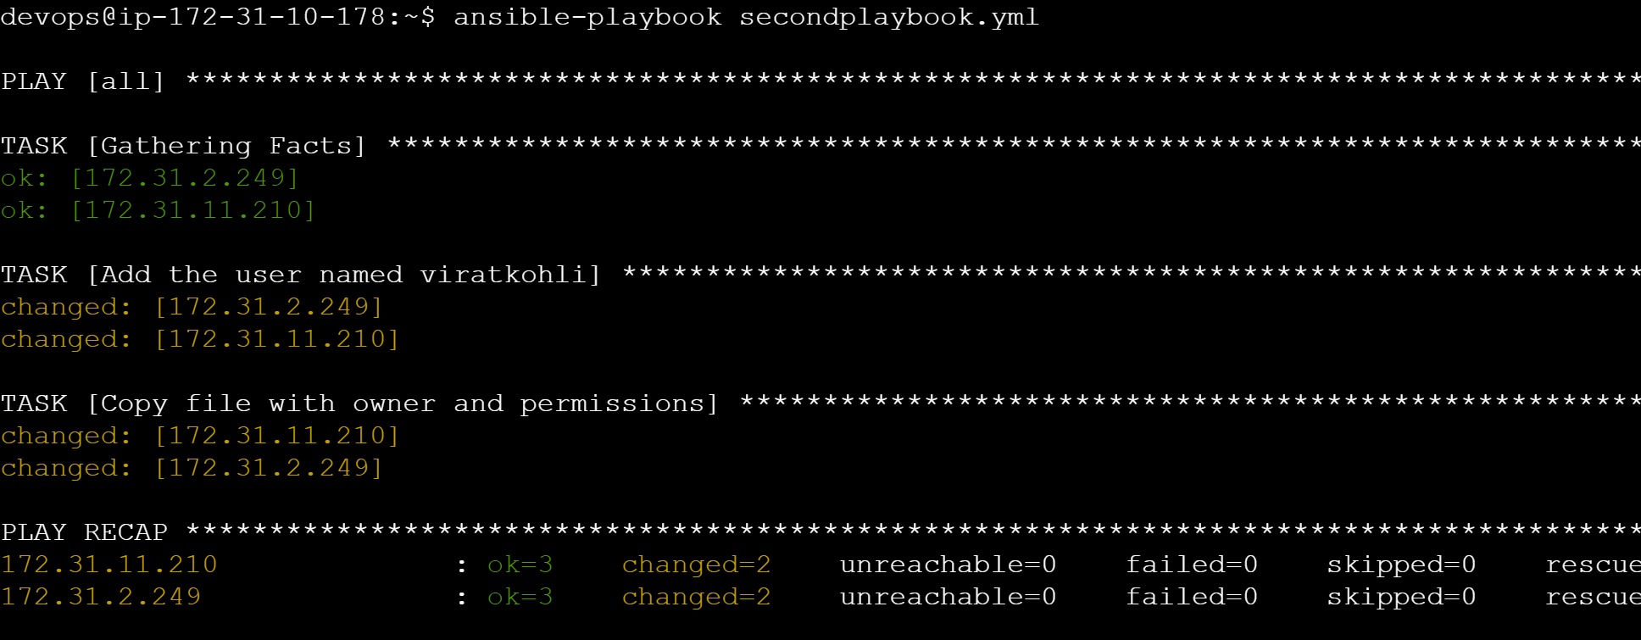

####

VARIABLES IN PLAYBOOK : When we need to use playbook as a template we use variables in the playbook . Variables are the values we can define or change later without making a lot of configuration changes in the ansible playbook

We can define a variable and later on we can pass on the variable in the playbook …now if tomorrow we want to change the name of the value we just need to change the variable name ..everywhere the changes will automatically implement

vi myansibleplaybook.yml

- hosts: all
become: yes
vars:
pkgname: apache2
filename: john.txt
dest: /home/devops/
tasks:
- name: Install '{{pkgname}}'
ansible.builtin.package:
name: '{{pkgname}}'
state: present
- name: Start service '{{pkgname}}', if not started
ansible.builtin.service:
name: '{{pkgname}}'
state: restarted
- name: Copy file with owner and permissions
ansible.builtin.copy:
src: '{{filename}}'
dest: '{{dest}}'

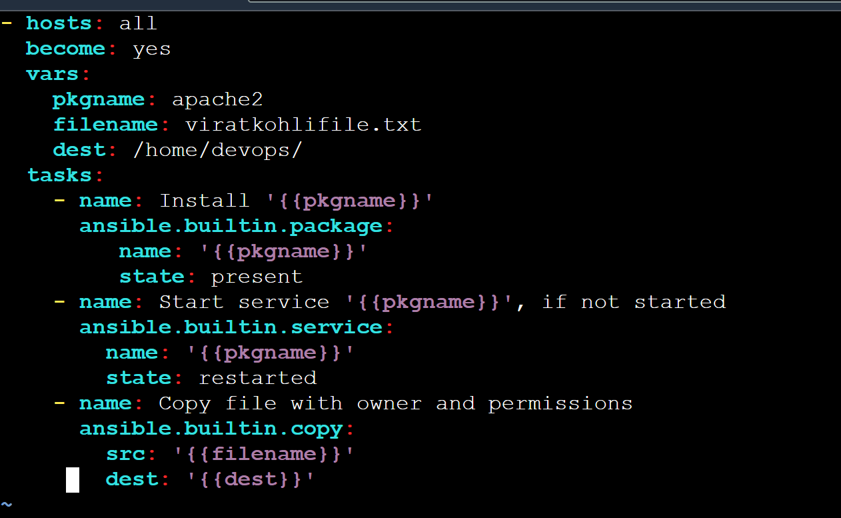

EXAMPLE:

Suppose we have some variable in playbook already passed in the playbook but we need to pass the new value of the same variable at the run time…for example earlier we were using apache as variable but now we want to replace that apache with docker and dont have permission to update the variable

This command will replace pgkname which is a variable to docker.io from apache2 in above example

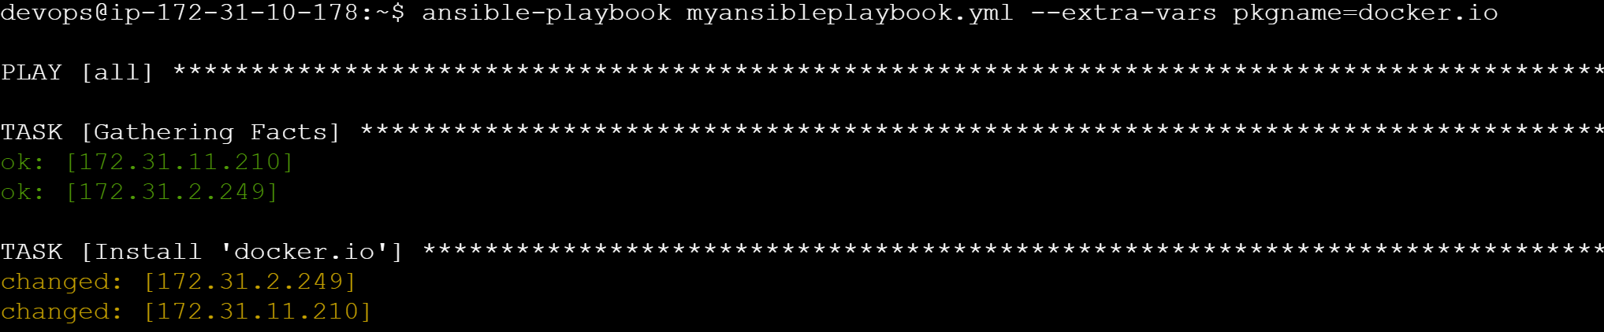

#ignore the error in restart because we have to start docker not docker.io ….
(service docker start not service docker.io start)

VAULT :

If you have some important data/pass or secret in the ansible playbook you need to secure the file so that someone who shouldnt know about that secret or pass in the file should not be able to access it. For this we use ansible vault where in we put the file a password protection to the file so that no one can access the same.

ansible-vault create myfile.yml

(put the pass when you type the password it will not be visible)

- hosts: demo
become: yes

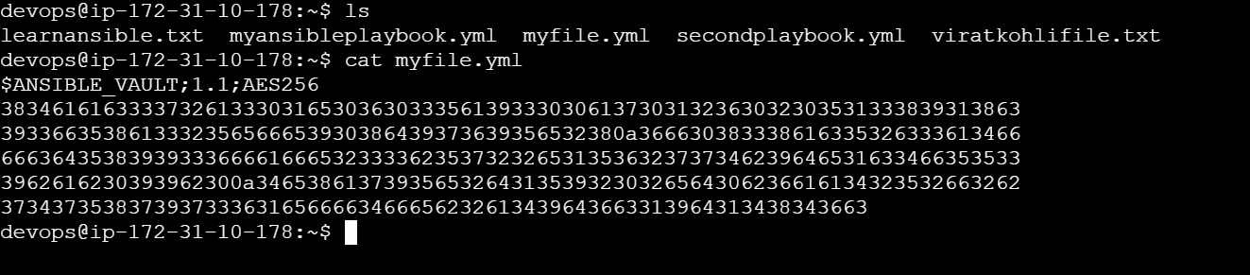

You will see the content of the file myfile.yml is encrypted

# now to edit the file

ansible-vault edit myfile.yml

# i want to change the password of the yaml file

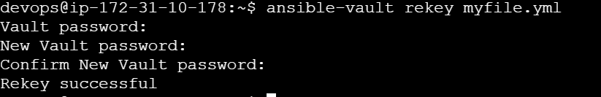

## NOW LETS TRY TO EXECUTE THE PLAYBOOK

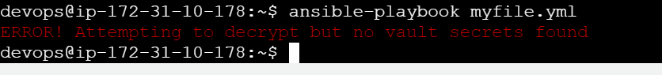

Error will come up
Use:

ansible-playbook myfile.yml --ask-vault-pass
